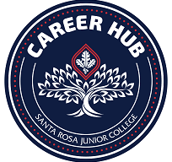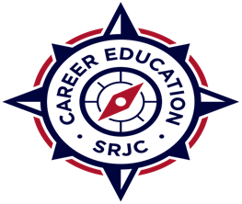
March 4, 2024

Dear Sonoma County Employers:
I would like to cordially invite you to participate in our upcoming SRJC Industrial Trade Technology Job Fair on Wednesday, April 24 from 11:00am – 1:30pm. This event will be open to all SRJC students and alumni. The job fair is designed to provide an opportunity for you to engage with our students through networking and sharing of both and job / Internships opportunities along with providing valuable industry information to student in these programs past and present. Students will benefit greatly by having access to interact face-to-face with our local employers!
We anticipate having students from all Industrial & Trade Technology programs.
Please register at the link below. Employer Registration will close on April 10, 2024
https://app.joinhandshake.com/career_fairs/47855/employer_preview?token=_UVB-EtzIEwdcR5WfPqmpDyQ5K7bhu9FFM2VszDu13obNEORKjAQKQ

***Event details and parking permits will be sent as we move closer to the date

Please reach out to connect with me if you have any questions. I look forward to seeing you on campus!

Warmly,

Ann Mansfield
Workforce Development | Santa Rosa Junior College
707.527.4622 |amansfield2@santarosa.edu

